**3 ] Bootstrap**

**3.1 Basic of bootstrap**

**3.1.1 Introduction of bootstrap**

Bootstrap is an open-source framework for front-end web development that helps developers create websites and web apps quickly and easily. It includes a collection of HTML, CSS, and JavaScript templates and tools, as well as optional JavaScript plugins.

Some key features of Bootstrap:

* Responsive development: Bootstrap is designed to enable responsive development of mobile-first websites. It includes a 12-column grid system that scales up or down based on screen size.
* Predefined classes: Bootstrap includes predefined classes for easy layout options.
* Mobile first: Bootstrap is developed mobile first, meaning that the code is optimized for mobile devices first, and then scaled up as needed.
* Accessibility: Bootstrap aims to make web design more accessible and uniform across different devices and screen sizes.

**3.1.2 Use of bootstrap**

We can use bootstrap using CDN kinks :

CSS : <https://cdn.jsdelivr.net/npm/bootstrap@5.3.3/dist/css/bootstrap.min.css>

CSS goes inside head section of HTML using link element.

Javascript : <https://cdn.jsdelivr.net/npm/bootstrap@5.3.3/dist/js/bootstrap.bundle.min.js>

JS goes at end of body section of HTML using script element.

**Utilities of bootstrap :**

* Background color : used to color background by adding simple classes in HTML element.

Ex : <div class="bg-warning text-dark">.bg-warning</div>

Here background color is yellow and font is black.

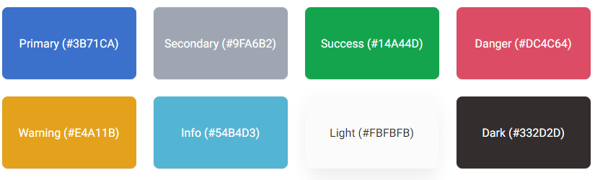

* Border : to quickly style the border and border-radius of an element.

For adding borders : .border , .border-top , .border-end , .border-start, .border-bottom

For removing borders : .border-0 , .border-top-0 , .border-end-0 , .border-start-0, .border-bottom-0

For color the border :

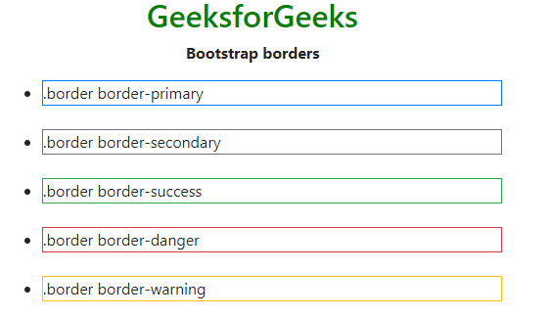

For border radius : .rounded , rounded-top , rounded-end , rounded-bottom , rounded-start , rounded-circle , rounded-pill

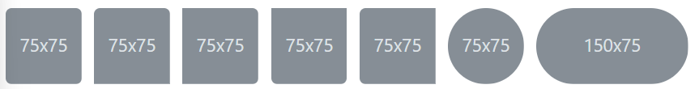

* Text color :



Ex : <p class="text-success">text-success</p>

* Display : Change the value of the display property.

Notation :

.d-{value}

Value : none , inline , inline-block , block , flex

Ex1 : <span class="d-block">d-block</span>

* Flex :

Flex direction : .flex-row , .flex-row-reverse , .flex-column , .flex-column-reverse

Justify content : .justify-content-start , .justify-content-end , .justify-content-center , .justify-content-between , .justify-content-around , .justify-content-evenly

Align items : .align-items-start , .align-items-end , .align-items-center , .align-items-baseline , .align-items-stretch

Wrap : .flex-nowrap , .flex-wrap , .flex-wrap-reverse

* Overflow : Adjust the overflow property

class : overflow-auto , overflow-hidden , overflow-visible , overflow-scroll , overflow , overflow-y

* Position :

class : position-static , position-relative , position-absolute , position-fixed , position-sticky

We can arrange elements using : {property}-{position}

Property : top , start , bottom , end

Position : 0 (0 edge) , 50 (50% edge) , 100 (100% edge)

* Shadow :

shadow-none : no shadow

shadow-sm : small shadow

shadow : regular shadow

shadow-lg : larger shadow

* Sizing :

w-25 : 25% width relative to the parent

w-50 : 50% width relative to the parent

w-75 : 75% width relative to the parent

w-100 : 100% width relative to the parent

w-auto : auto width relative to the parent

h-25 : 25% height relative to the parent

h-50 : 50% height relative to the parent

h-75 : 75% height relative to the parent

h-100 : 100% height relative to the parent

h-auto : auto height relative to the parent

* Margin and padding :

Notation : {property}{sides}-{size}

Property :

m - for classes that set margin

p - for classes that set padding

Sides :

t - for classes that set margin-top or padding-top

b - for classes that set margin-bottom or padding-bottom

s - (start) for classes that set margin-left or padding-left

e - (end) for classes that set margin-right or padding-right

x - for classes that set both left and right

y - for classes that set both top and bottom

blank - for classes that set a margin or padding on all 4 sides of the element

Size : 0,1,2,3,4,5,auto

* Text :

Text alignment : text-start , text-center , text-end

Text transform : text-lowercase , text-uppercase , text-capitalize

Font size : fs-1 to fs-6 (like h1 to h6 tags of HTML)

Font weight and italics : fw-bold , fw-bolder , fw-semibold , fw-medium , fw-normal , fw-light , fw-lighter , fst-italic , fst-normal

Line height : lh-1 , lh-sm , lh-base , lh-lg

Text decoration : text-decoration-underline , text-decoration-line-through , text-decoration-none

* Z-index :

Class : z-3 , z-2 , z-1 , z-0 , z-n1 (negative 1)

**3.1.3 Structure of bootstrap**

**Bootstrap Grid System :** allows up to 12 columns across the page.

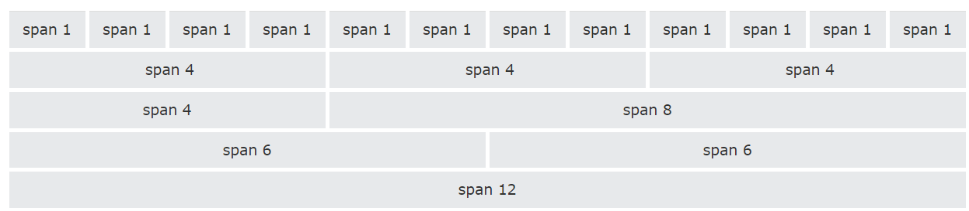

Notation :

row-{grid class}-{size}

col-{grid class}-{size}

The Bootstrap grid system has four gird classes:

* xs (for phones - screens less than 768px wide)
* sm (for tablets - screens equal to or greater than 768px wide)
* md (for small laptops - screens equal to or greater than 992px wide)
* lg (for laptops and desktops - screens equal to or greater than 1200px wide)

Size : 1 to 12

Ex :

<div class="row">  
  <div class="col-sm-4">.col-sm-4</div>  
  <div class="col-sm-4">.col-sm-4</div>  
  <div class="col-sm-4">.col-sm-4</div>  
</div>



On mobile phones or screens that are less than 768px wide, the columns will automatically stack

